Green space committee
Before we begin; We will need to see FACTUAL evidence that lot 87 has the "green space" that you all are saying it does.
We will NOT except one of the four maps that all seem to be different as FACTUAL evidence.
Tracy Mace has provided us with FACTUAL evidence in the form of pictures clearly showing that there was NO "green space" as the owners of many years ago used to park their RV in that "green space".
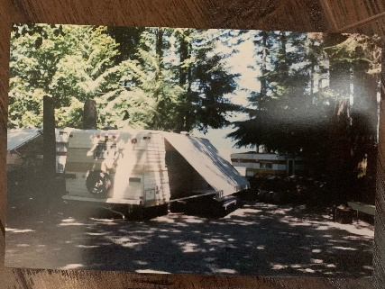
Please see attached pictures as one of our factual pieces of evidence.
This has also been backed by several members of the park stating there was NEVER "green space" in this spot. However, as you are requesting actual facts, here are some more.
When our parents purchased this lot back in 2010 here are some more pictures clearly showing NO "green space"; in fact, as you can clearly see there was very limited to almost NO greenery around the sides and back of the lot. Our family has spent over a decade planting more than 15 cedars as well as maintaining and restoring the greenery back into this lot.
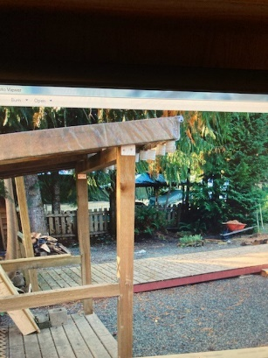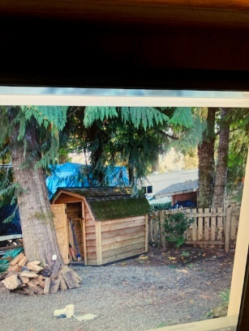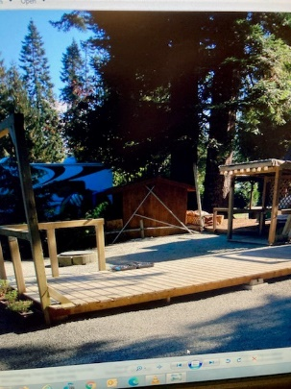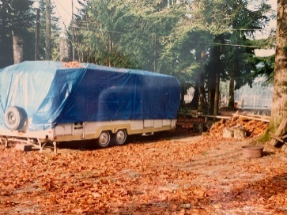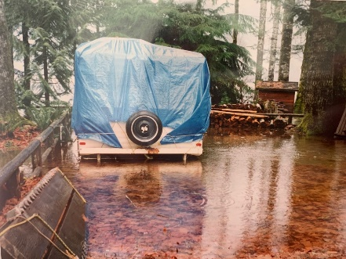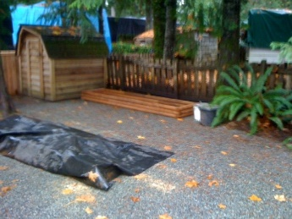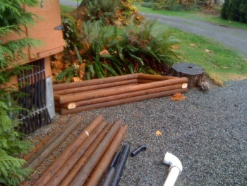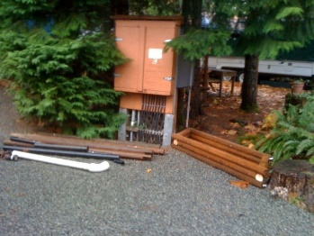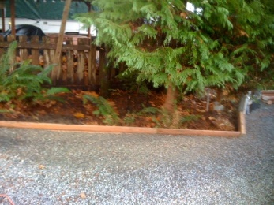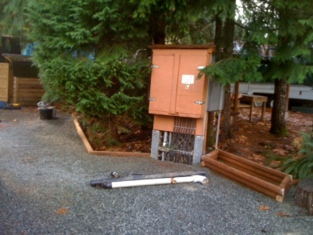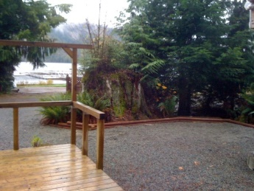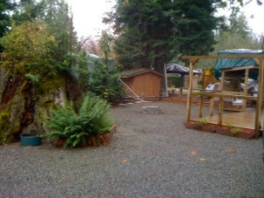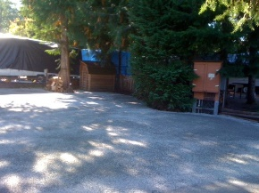
More factual evidence from prior executives in the form of emails has also been attached.
This dates back to 2011.... over 10 years ago. Storm Shelters and sheds all APPROVED by said executive.
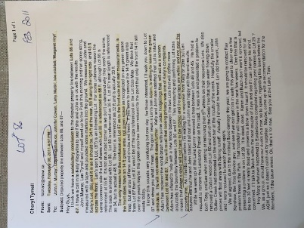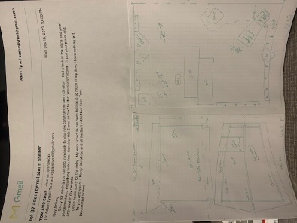
The membership can NOT legally take that away or make changes to this 10 + years later.
Unless you can provide us with FACTUAL evidence, this "green space" committee can remove us from this discrepancy, and we will not move forward with the lawyer.
We take this VERY personal as our family have been outstanding members of this park for 30 years; we have always followed the rules and been very concise as to what is right and wrong. We love this campground and all the greenery around it and thrive to always do our part to protect that. Our parents have gone above and beyond helping who ever and whatever needs help. You have caused a very stressful situation and we will not forget this.
Adam, Erin, Nikki and Joey

