Reference / Nearest Lot Numbers:

Lot 68 & 69

Members Affected or Neighbouring:
Tyrrell / O'Connor
Description of Green Space
- This green space is a strip that runs from the road to the creek between lots 68 and 69
- There is a large old stump on the road side of the green area.
- On the creek end of the green area Lot 69 has a shed.
[TYE OCONNOR]
- Campsite 69 was purchased by Pat O’Connor’s mother, Dorothy and Lyle Foster in 1978 from Verla & Ken Evans.
- Mrs. Evans personally showed Pat Dorothy and Lyle the lot boundary.
- Mrs. Evans personally confirmed the dimensions as, “60 feet, front and back – same as that one”, as she motioned toward Lot 70.
- Mrs. Evans reconfirmed the lot boundary during the placement of a fence in 1978.
- Mrs. Evans marked the stump with an axe where its root protruded into Lot 69, asking that it not be altered when installing fence, and the fence was installed accordingly.
- The fence location and lot boundary was acknowledged
  - by Verla Evans in 1978
  - by the member who later handled the transfer from Pat’s mother to Pat and Kaye
  - by any executive or other members involved or concerned with lot boundary, grounds, tree trimming or greenspace matters
from 1978 up until the drafting of the Green Space Committee Report of January 2020.
- The green space was historically narrower at the river due to the stump and large maple close to the road, and curve of the river.
- Early drawings, though not to scale, represent this space as a wedge.
- Note the 1978 fence in the 1986 and 1991 photos.

- Trees and shrubs have been cut away from this space on the Lot 69 side. The cutting and damage to this green area has happened in the last year or two.
[TYE OCONNOR]
- This statement is factually incorrect.
- The park’s tree service removed maple trees from the greenspace.
- Lot 69 added to this greenspace - a pine tree, several cedars and at least one fern.
- The owners of Lot 69 place high value on greenspaces in general, both here at Honeymoon Bay and in a Garry Oak ecosystem in Saanich they have stewarded for over 50 years.

Recommendations
Re lot 69
- The shed should be moved to within the Lot 69 boundaries.
[TYE OCONNOR]
- The owners of Lot 69 confirm that the shed is within the boundary established in 1978.
- Photos from 1986, 1991 and 2006 show the area as a gravel portion of Lot 69.

- Gravel should be removed and the area should be replanted with trees or shrubs.
[TYE OCONNOR]
- Photos from 1986 and 1991 shows the area is gravel to the fence/boundary.
- Note the vegetation visible in 1991 includes a number of maple trees outside the fence.
- Prior to fall 2006, the rotting fences was removed.
- The 2006 photo shows hemlocks planted by the owners of Lot 68 behind the former fence location.
- Note the vegetation visible in 2006 does not include a number of maple trees outside the former fence location.
- It does include a daphne that was present before the fence was removed, inside the fence, and within the boundary.
- After 2006, cedars were planted by Lot 69 in front of the hemlocks.
- After which, the shed was turned 90 degrees and positioned along the lot boundary previously demarcated by the fence.
- The owners confirmed while it was in place, the fence did not appear to move, and since its removal, nor have the hemlocks and cedars planted adjacent to the 1978 boundary.

- Suggest landscape ties be put in to mark the boundary of this green space on the lot 69 side. Landscape ties already mark the boundary on the lot 68 side.
[TYE OCONNOR]
- As suggested, landscape ties were placed when the fence was removed, to mark the boundary.
- The landscape ties were removed in 2019, prior to the development of the 2020 Green Space Committee’s report, and without Lot 69’s knowledge.
- It is not clear why Lot 68 is referenced under notes on Lot 69, as the two lots do not share a boundary, unless the intention is in the interests of Lot 68. It does, however cause Lot 69 to recall some relevant history regarding this greenspace.
- The owners of Lot 69 distinctly recall a past “kerfuffle” that resulted in the placement of a chain across the fire lane.
- The chain was placed by certain members of the day, to prevent the Spelt’s, then owner of lot 68, from parking a visiting motorhome either entirely or partially in the greenspace.
- The fence did not impede parking of the motorhome, the rear of which, when present, would position closer to the Lot 69 boundary than the front, due to the stump at the front and wedge shape of the green space bordering Lot 68.
- As the Lot 69 fence was not in question during this dispute, it suggests the matter in question was whether the greenspace between Lots 68 and 69 was a rectangle (which was the disputing members’ position) or wedge shaped (the Spelt’s position).
- The owners of Lot 69 didn’t were not impacted by this dispute as the motor home visited rarely, and they were nice people, but more importantly, that dispute in question was – and always has been – on the other side of the fence.

- An agreement documenting this for Lot 69 should be placed on the members file, signed both by the member and the 2020 executive.
[TYE OCONNOR]
- Many lots have green areas such as trees of various sizes, or greenery within the lot’s boundary, and tress in the park have always had some degree of protection. While some may see this as a detriment, others consider these a “feature”.
- In weighing such matters, the executive may wish to avoid setting precedence by negotiating an exchange of green features within certain lot boundaries for alternative spaces not currently within lot boundaries. Is there sufficient space available for exchange to treat all members equitably for such exchange?
- The report was prepared without consultation with the owners of Lot 69.
- The report was prepared in consultation with other members.
- The owners of lot 69 are seniors of a vulnerable age, but their recollection of the history is quite sound, and they have no intention of expanding or contracting the space allocated to the family in 1978.
- If the comments on Lot 69 in the January 2020 Green Space Committee Report were to be factual, which the owners of Lot 69 have reason to believe is not to be the case, the conditions proposed are inequitable and not in accordance with the conditions set upon several other members who have encroached upon greenspace in recent years.
- The owners of Lot 69 are unwilling to accept these terms.
- The owners of Lot 69 recognize the significant burden on the executive to reach consensus and settle this matter in a timely fashion.
- The owners of Lot 69 recognize the significant challenge on the executive to produce artifacts that can be acknowledged as an official record of lot boundaries.
- The document titled “Honeymoon Bay Association Lot Sizes” provided by the 2019 HBRA Green Spaces Committee has not been cited in HBRA records shared with members as to its origin or date of inclusion to the official record of the HBRA.
- This document was not part of the original purchase documents provided to original purchasers.
- A handwritten list has been referenced that has not been cited in HBRA records shared with members as to its origin and date of inclusion to the official record of HBRA.
- The measurements in both the document and handwritten list do not confirm to the boundary of Lot 69 demonstrated at the time of purchase.
- The owners of Lot 69 recommend motions to:
- Engage a qualified surveyor to survey the HBRA property boundary as a first step.
- Consult with a notary on an appropriate method of determining and documenting lot dimensions that would be consistent legal precedence in the province of British Columbia.
- Consult with a notary on an appropriate strategy to include such documentation to the permanent record of the HBRA.
- Engage a qualified surveyor to map the park and place steel corner posts upon each lot at each corner point of each lot boundary and common space in a manner that aligns with legal precedence in the Province of BC
- The owners of Lot 69 feel that this approach is more equitable, will reduce the likelihood of future legal challenge, may increase options for future changes to ownership structure, and is more appropriate to the value of membership transfer transactions.
- At the very least, this course would define lot boundaries in an accurate and defensible manner.

1986
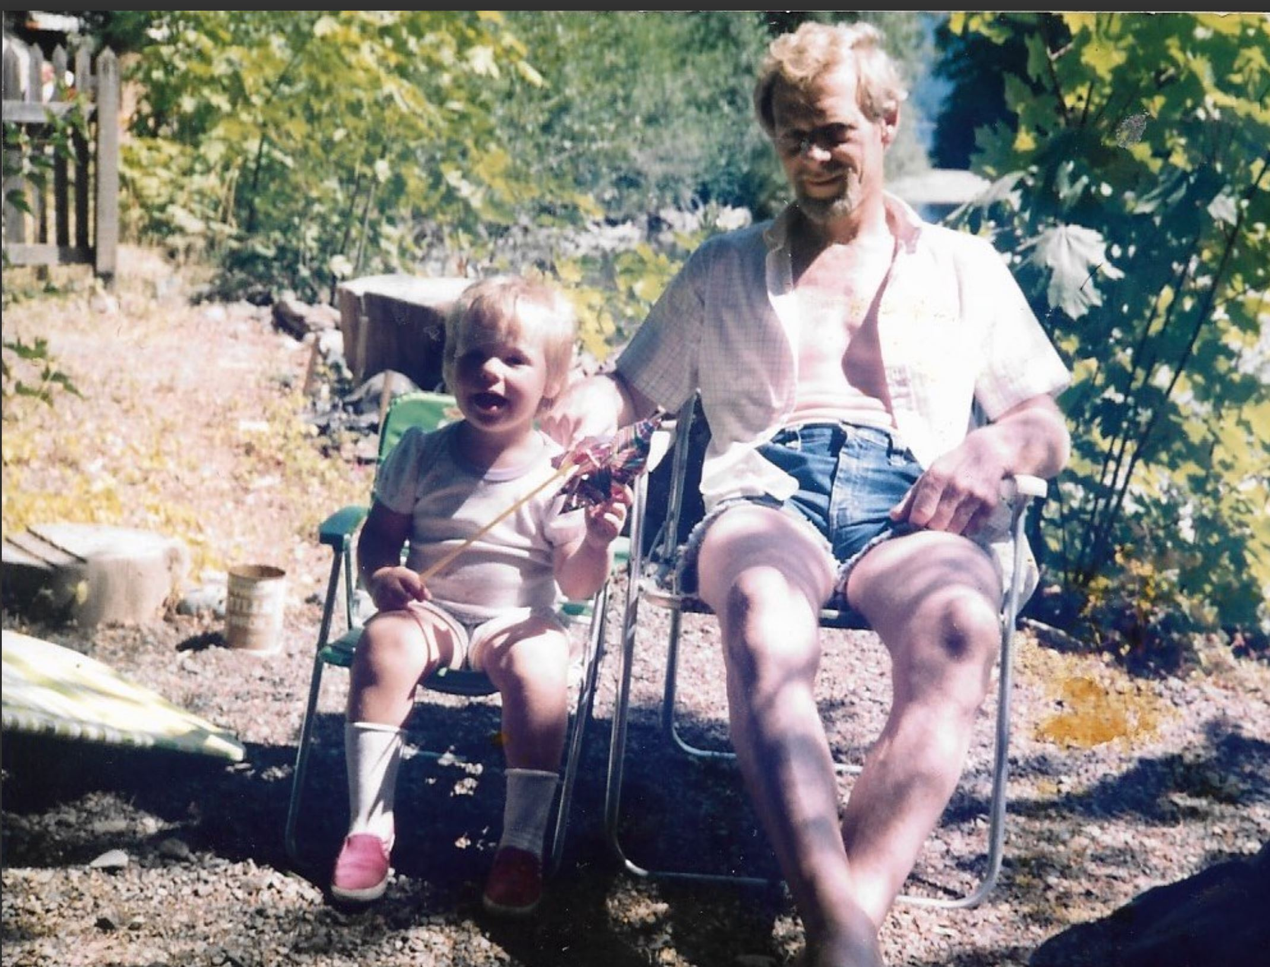

1990
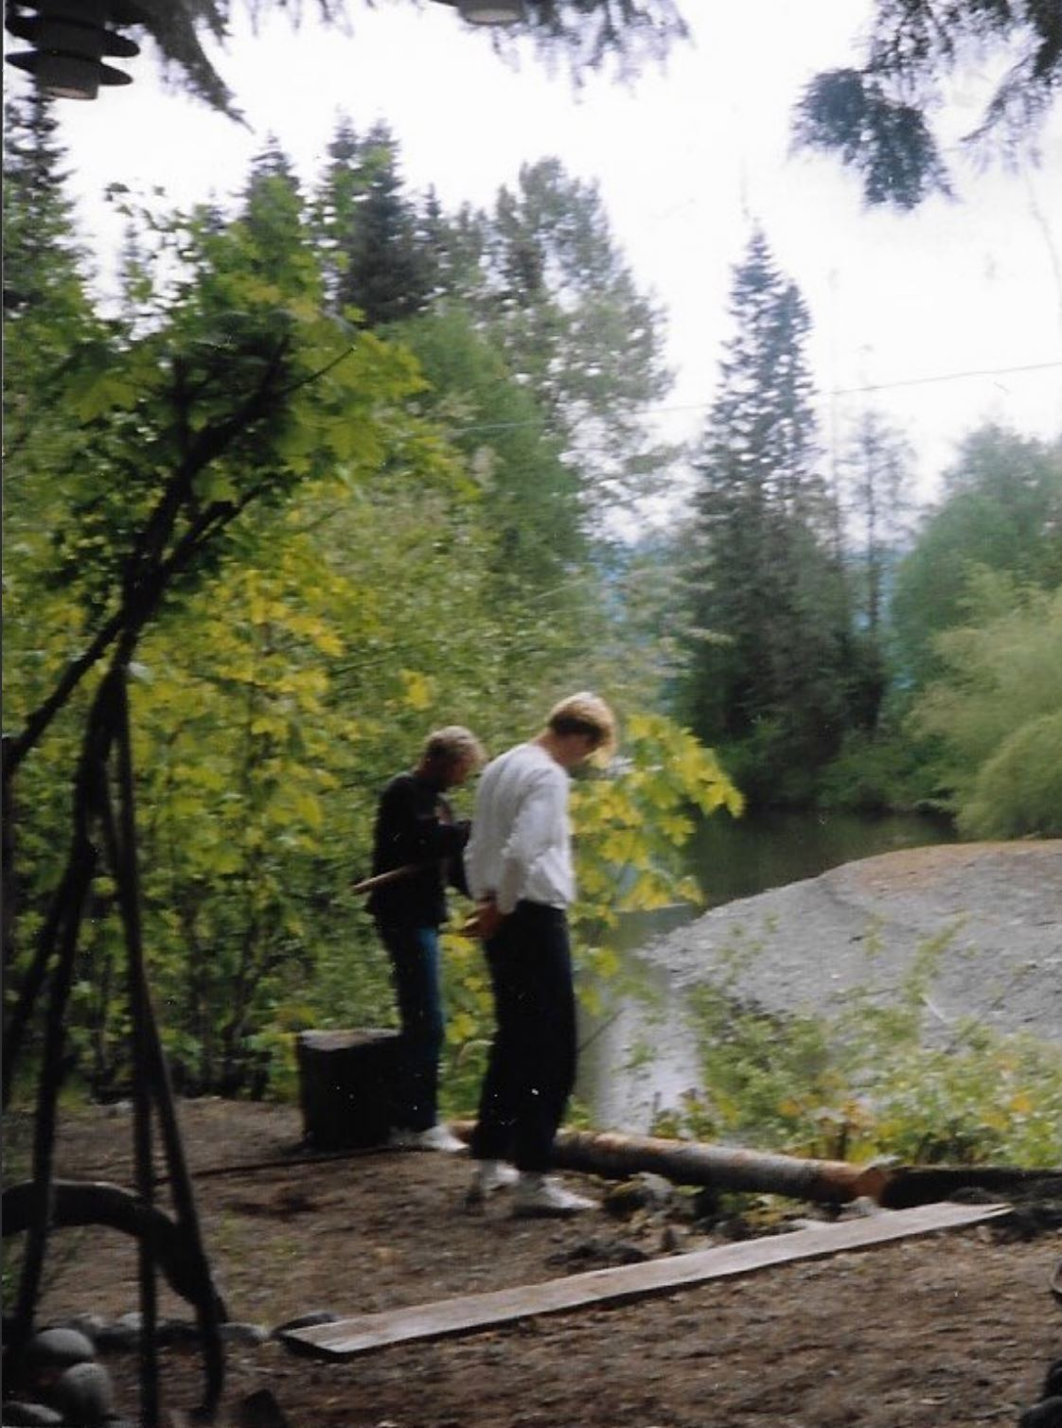

1991
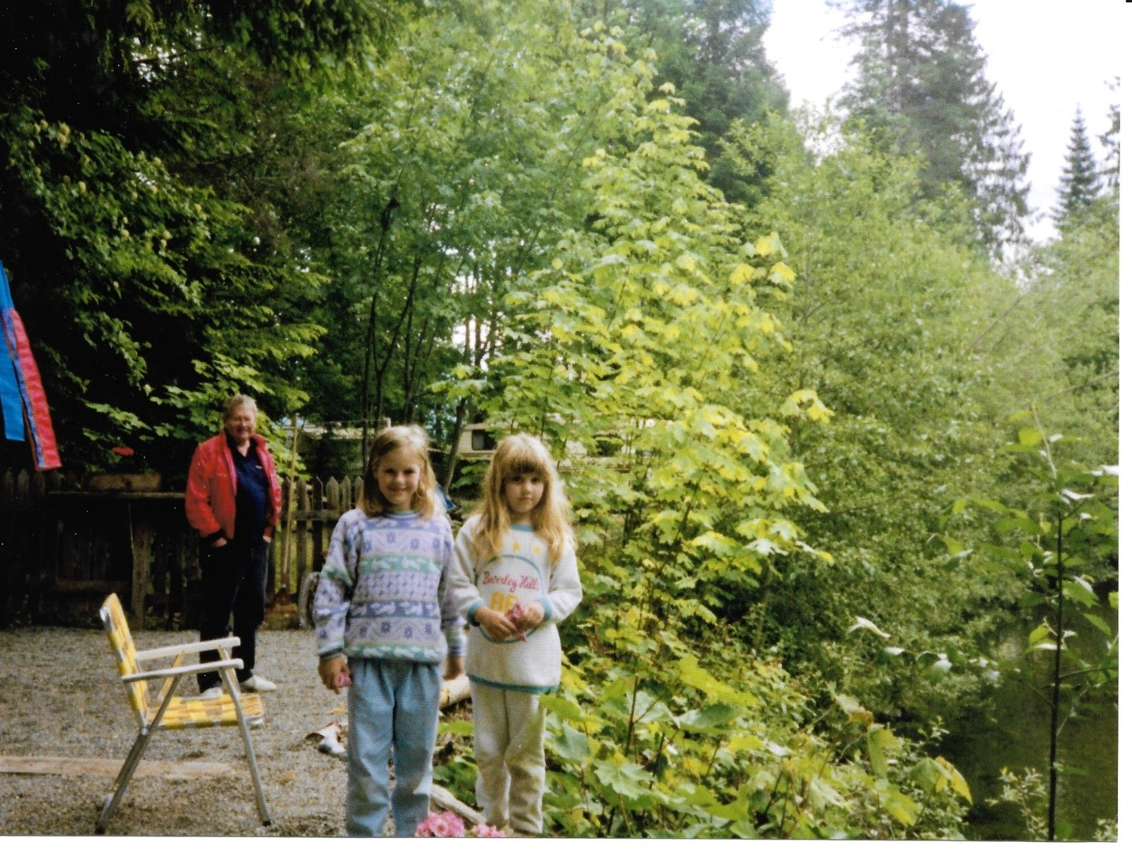

2006
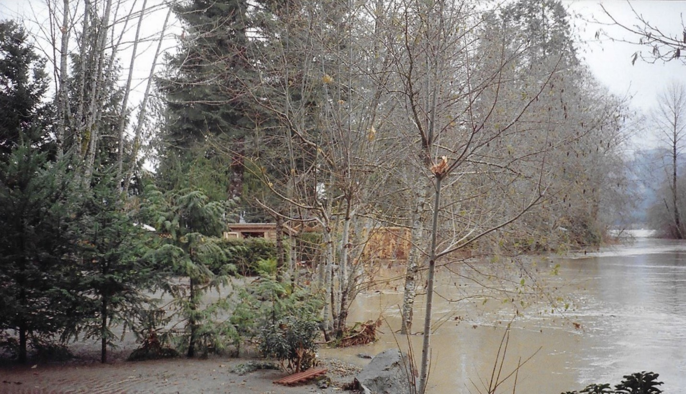
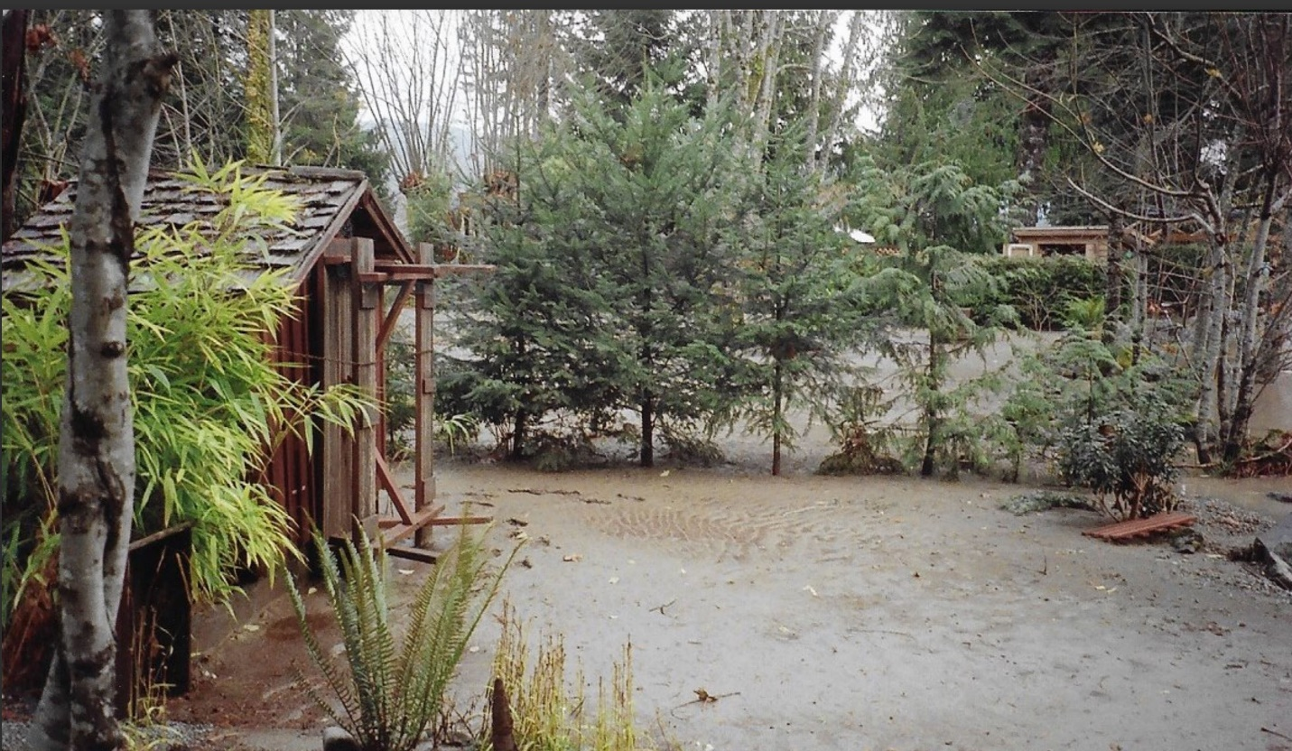

Re lot 68
- There was historically a use of the Lot 68 parking area as a Fire Lane Access to the creek for water. This is no longer required with new water systems in place.
- Lot 68 official dimensions confirm that most of this area is within the lot and not green space. The members of lot 68 are using an additional 6 feet at the back of the lot in exchange for 6 feet less at the front of the lot. This preserves a large stump area at the front as green space. This change in dimensions was known by a past executive but did not go to the membership for approval as official change.

OPTION A
- That the members of lot 68 continue to use the lot with the current actual dimensions. When the lot is sold the area could revert to the original dimensions. In this case an area by the creek would need to be transformed from gravel to green space, and a green space on the road side could be impacted. With this option an agreement should be placed on the membership file.
- Official Original Front 71, Left 59, Back/Creek 51, Right 42
- Current Actual Front 65, Left 59, Back/Creek 57, Right 42
OPTION B
- That it be taken to the membership to officially change the boundaries of lot 68 to:
- Current Actual Front 65, Left 59, Back/Creek 57, Right 42 (which preserves a large historical stump in the green area on the road side)

